Daemon Threads (Invisible or background threads)

- The threads which are executing in background.
- Example: Garbage collector, Signal Dispatcher, Attach Listener
Objective:
- To provide support for non-daemon or user threads or main thread.
Example: If the main thread runs with low memory, then JVM runs Garbage Collector (Daemon thread) with high priority to destroy useless objects to free the memory. With this free memory, main thread can continue its execution.
Methods:
public boolean isDaemon()
public void setDaemon(boolean b)
Characteristics:
- Usually Daemon threads having low priority. But based on our requirement, daemons threads can run with high priority also.
- We can change daemon nature before starting of thread only. But if try after starting a thread, it throws IllegalThreadStateException.
- By default, main thread is non daemon. For all remaining threads daemon nature will be inherited from parent to child. i.e if the parent thread is daemon, then automatically child thread also daemon. If parent is non daemon, then automatically child thread also non daemon.
- It is impossible to change the daemon nature of a main() method thread because it is already started by JVM. It has to be set before threads starts.
- Whenever last non daemon or user thread terminates, then automatically all the daemon threads will be terminated automatically irrespective of their position.
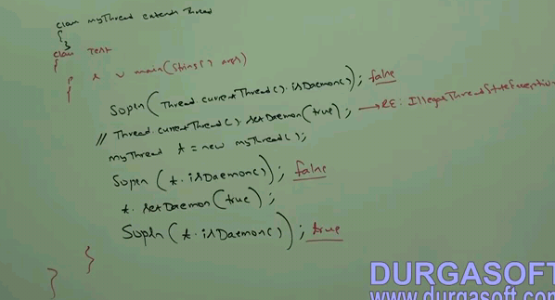

Example: Whenever last non daemon or user thread terminates, then automatically all the daemon threads will be terminated automatically irrespective of their position.
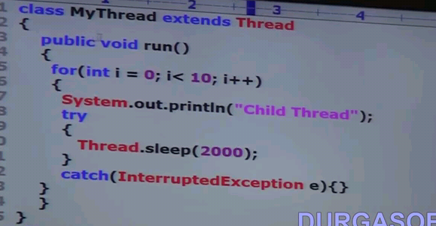
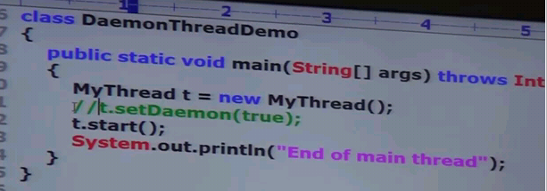
Case1:
Daemon nature of MyThread is commented. Then both main thread and child are non daemon threads.
Both will be executed until their completion
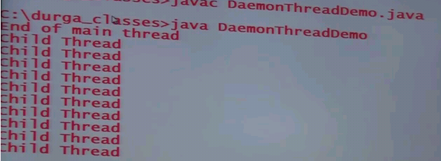.
Case2:
Daemon nature of MyThread is uncommented. Then main thread is non daemon and child thread is daemon thread.
Once main thread terminates, and then automatically child thread will be terminated immediately.
